Nov-Dec 2019 Events

Lunch and Learn: Community Reinvestment Act
Get an overview of the Community Reinvestment Act and learn how nonprofits and entrepreneurs can partner with banks to access donations, financing, advocacy, and volunteer service.
Thursday Nov 14th- Noon. ___by invitation only. Contact cwhitworth@mail.wvu.edu

Learn:
- What banks look for when developing partnerships with community-based organizations.
- What type of activity “qualifies” as CRA-eligible activity.
- How to make the best pitch.

WVU Center for Service and Learning: Introductory Community Partner Training with iServe Basics
The WVU Center for Service and Learning seeks to connect students with learning opportunities through community engagement. iServe.wvu.edu is our volunteer recruitment platform available to non-profits, agencies, and campus programs that serve communities. If you are not already an official partner of the CSL, you may be missing out on a host of other valuable benefits. Visit service.wvu.edu If you’d like to attend or to learn more about partnership, contact: cwhitworth@mail.wvu.edu
Nov 19th 2PM-4PM-One Waterfront Place-Room 4106 (for CSL Partners Only)

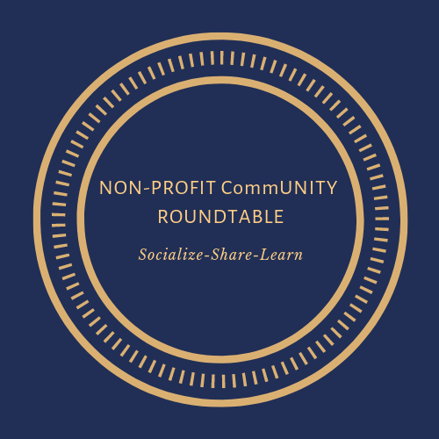
Non-Profit CommUNITY Roundtable Gathering Host: ReTails by M-SNAP, Morgantown Mall. Marketing for Non-profits - Common Challenges, Innovative Strategies, and Best Practices with Sarah Rogers, President, & Meredith Eddy, Digital Media Strategist, of Blaine Turner Advertising; Barbara Grigg, Director, Bless the Pets; and Amanda Posey, Marketing & Communications Dir., United Way of Mon and Preston Counties
Sunday, December 8th, 4:30pm – ReTails by M-SNAP, Morgantown Mall

